**Early Prediction for Chronic Kidney Disease Detection: A**

**Progressive Approach to Health Management**

**1. INTRODUCTION**

**1.1 Overview**

Chronic Kidney Disease (CKD) is a major medical problem and can be cured if treated in the earlystages. Usually, people are not aware that medical tests we take for different purposes could containvaluable information concerning kidney diseases. Consequently, attributes of various medical testsare investigated to distinguish which attributes may contain helpful information about the disease. Theinformation says that it helps us to measure the severity of the problem, the predicted survival of thepatient after the illness, the pattern of the disease and work for curing the disease.

In todays world as we know most of the people are facing so many disease and as this can be cured if we treat people in early stages this project can use a pretrained model to predict the Chronic Kidney Disease which can help in treatments of peoples who are suffer from this disease.

The past decade has seen an increasing focus on chronic kidney disease (CKD) and its attendant complications, which has resulted in improved understanding of their impact on health-care resources. The early detection of CKD has been facilitated by the implementation of routine reporting of estimated glomerular filtration rates (eGFRs) and by education of primary care physicians on the implications of detecting a decreased eGFR with respect to patient safety as well as to cardiovascular and renal outcomes.

The goals of early CKD detection are to prevent CKD progression and associated complications, thus improving patient outcomes and reducing the impact of CKD on health-care resources. This Review examines the benefits of the early detection of CKD, and describes the limitations of current knowledge with respect to screening, early detection and treatment, as well as the unintended consequences of detection. In addition, this article highlights what is currently known about cardiovascular and renal outcomes and the effects of intervention in patients with CKD.

**1.2 Purpose**

The rationale for testing asymptomatic people for CKD is that earlier detection might allowfor the implementation of therapeutic interventions and avoidance of inappropriate exposure to nephrotoxic agents, both of which may slow the progression of CKD to end-stage kidney disease

Chronic Kidney Disease (CKD) is a major medical problem and can be cured if treated in the earlystages. Usually, people are not aware that medical tests we take for different purposes could contain

**2. Problem Definition & Design Thinking**

**2.1 Empathy Map**

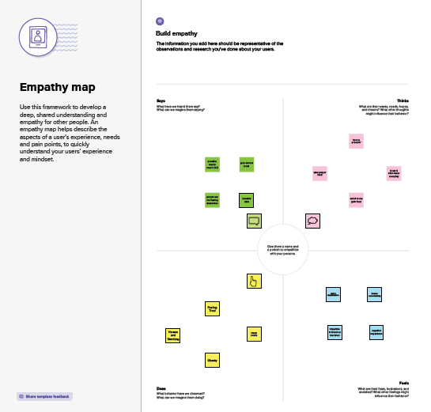

**2.2 Ideation & Brainstorming Map**

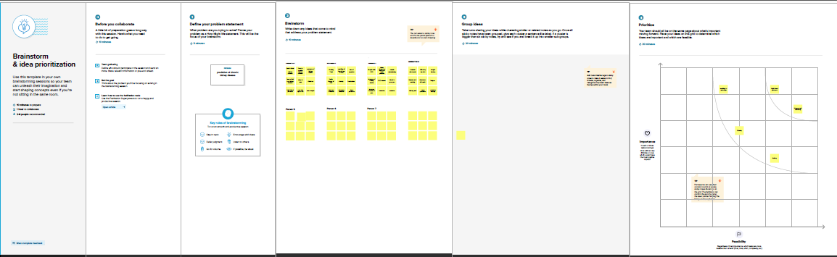

**3. RESULT:**

**Home page:**

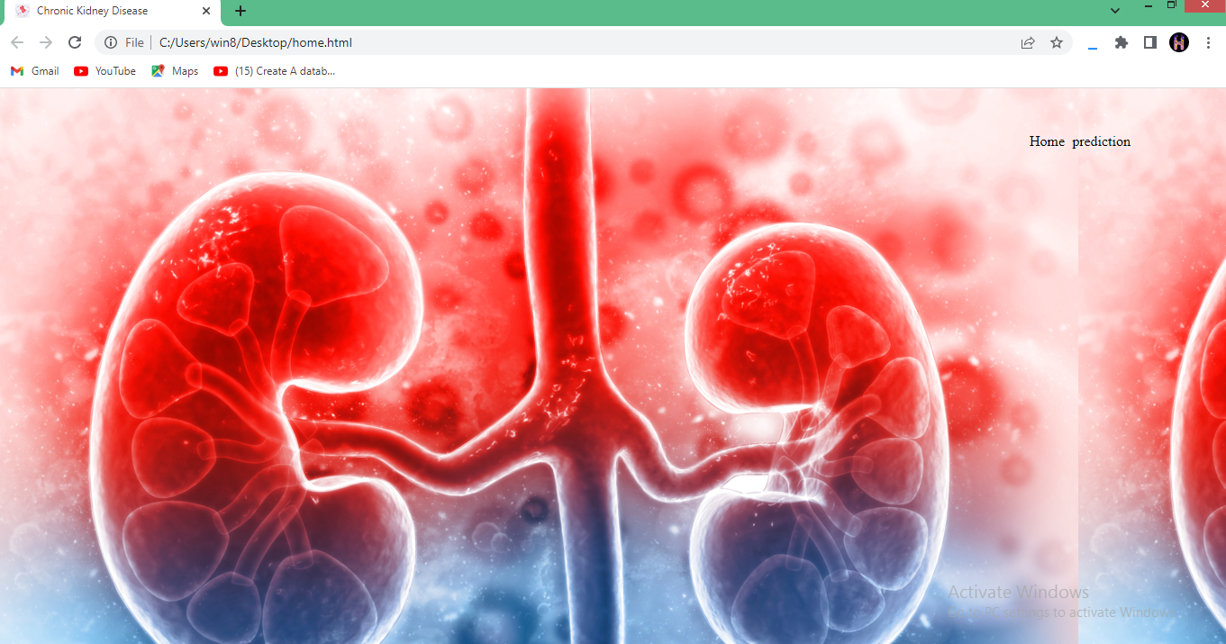

**Input page:**

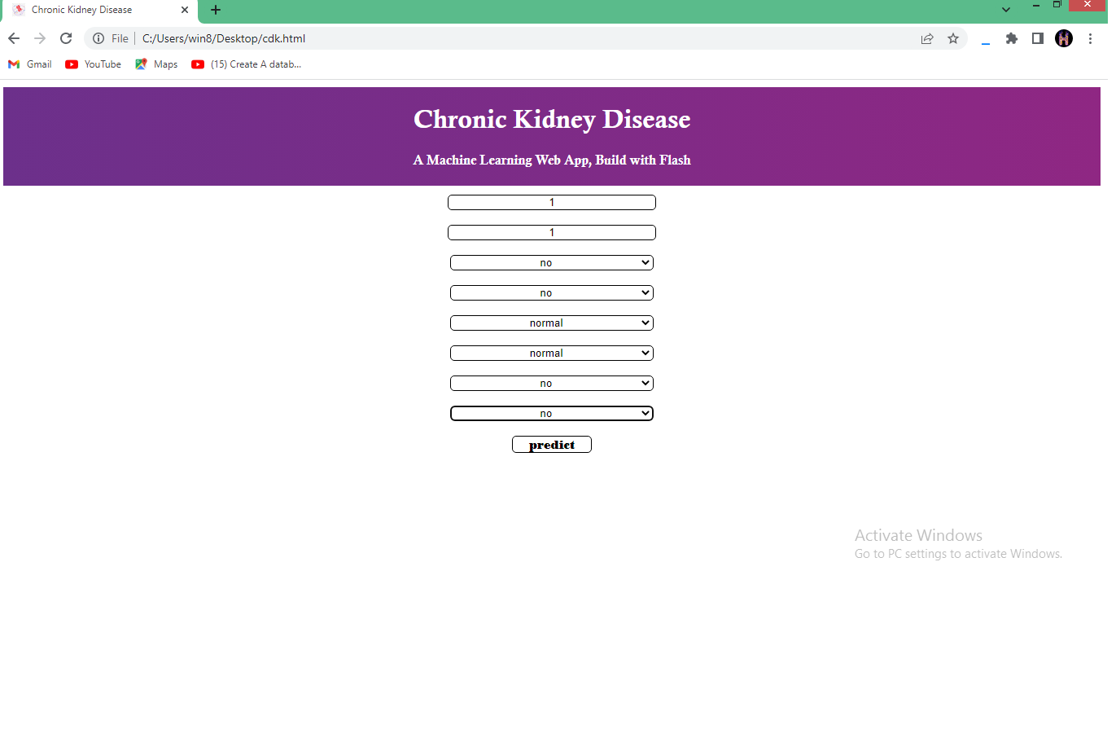

**Result:**

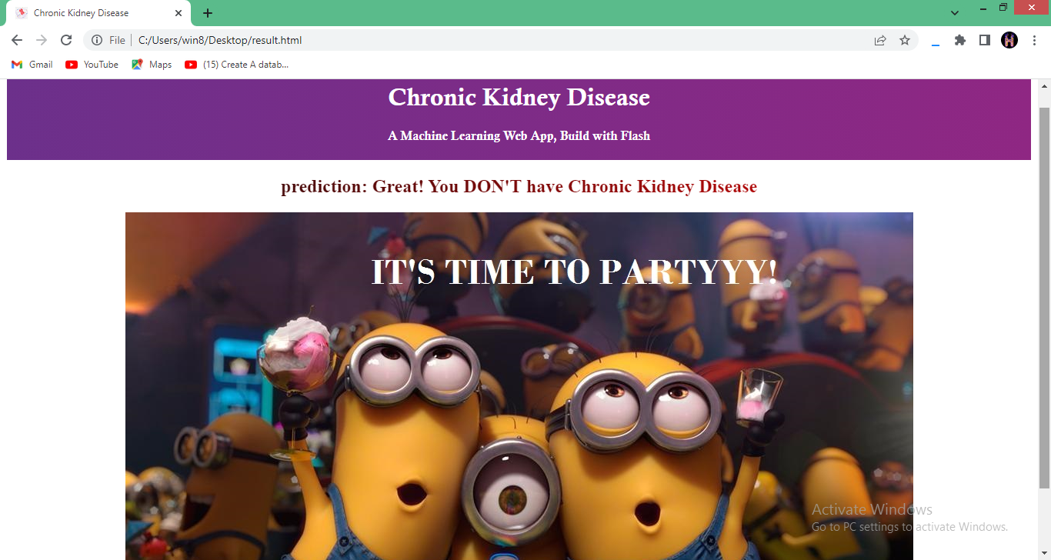

**4. ADVANTAGES & DISADVANTAGES:**

**ADVANTAGES :**

* Predict of ckd system can give correct result and prediction
* The system can access easy and fast
* It will save the time of patient
* We can not to pay to check the kidney disease
* This is available for any time

**DISADVANTAGES:**

* It reduces the effectiveness of legitimate advertising.
* It raises costs for everyone who uses the Internet.
* It exposes children to inappropriate material.
* It didn’t give any doctor consultation
* We need some internet connection

**5. APPLICATIONS**

**Web-based applications**

The internet has become one of the most important sources of health information for patients and their families. Recent studies suggest that most adults seek health information online.14 Many digital educational materials have been available on-line for patients with CKD by professional societies and patient advocacy groups, satisfying the knowledge component of Kolb’s learning cycle. Systematic reviews of these educational materials suggest that most are adequate for use as determined by validated instruments, though relatively few are outstanding and many are written at a literacy level too high to be appreciated by most patients with CKD.15,16 A well-established repository of educational materials for patients with kidney disease is the National Kidney Disease Education Program (NKDEP), which sponsors an initiative to promote kidney disease education via digital media. The NKDEP website contains several links to kidney disease educational topics (www.nkdep.nih.gov), including pamphlets available for download. Importantly, the website content is directed at an elementary school level reading capability, and has been modified based on an iterative process of review.17 This same iterative process was used in the development of the Safe Kidney Care Cohort study website (www.safekidneycare.org) which provides information to patients, family members and providers, on topics relevant to patient safety in CKD.18 Health education videos may also be found on these websites as adjuncts to the written educational materials, or they may stand on their own on websites such as YouTube.

**Virtual support groups**

The Internet has also become a resource for the development of social support systems for those affected by chronic diseases, including kidney disease.19 Internet support groups with videoconferencing and virtual group education classes, facilitated by health educators or peer leaders, deliver chronic disease education and promote collaborative problem solving, self-reflection and conceptualization. While these types of classes have not yet been tried for patients with CKD, a trial comparing virtual diabetes classes to in-person classes demonstrated equal improvements in glycemic control among participants in both groups (decrease in glycosylated hemoglobin of 0.4-0.5% groups).20 Importantly, these classes facilitate both the knowledge and understanding components of Kolb’s learning cycle, and they have been well received by older individuals with chronic illnesses, who report appreciating the benefits of group learning without enduring the burden of travel.21

**Text Messaging**

Short message service (SMS) text messaging has been the most extensively studied telehealth application in chronic diseases, though it is still a burgeoning area for research for individuals with CKD. Text messages can deliver succinct educational reminders to patients, prompting them to review previously learned material, as well as web links with access to more in-depth educational content.22 Standard educational messages satisfy the knowledge component of the Kolb learning cycle, and may be sent in bulk via one-way interactions to many patients simultaneously. More tailored two-way text message communications can also be sent to individual patients by health workers or health educators, allowing to not only self-reflect but also apply their knowledge, completing the Kolb learning cycle..23 One challenge of text message mediated education lies in the need to transmit substantial education with few words or written characters. Nonetheless, studies of text-based interventions have been associated with improved medication adherence,24 greater tobacco cessation,25 increased weight loss among obese adults,26 and enhanced diabetic control.27 Still, there is a paucity of information about the best way to tailor text-based educational programs for different subgroups of individuals, based on age, gender, socioeconomic status, or type of chronic disease. In particular,

**6. CONCLUSION:**

Telehealth is largely nascent in the field of nephrology but early examples illustrate great promise to increase general awareness and understanding of kidney disease among patients and to enhance renal knowledge and optimal CKD management among primary care providers.

With suboptimal levels of CKD awareness among both of these important stakeholder groups, the use of telehealth applications and other health information technology tools for education rightfully engender great excitement. Care will be needed to ensure that these tools are widely accessible, designed for individuals with all levels of e-literacy.

Further, rigorous evaluation will be critical to determine benefits relative to traditional educational modalities, and to identify and mitigate unanticipated consequences. Nephrology education is gearing up for the future—fasten your seatbelts!

CKD at its mildest stage is asymptomatic; at its most severe stage, it is characterized by uremia. End-stage kidney failure denotes CKD that necessitates kidney replacement therapy (dialysis or transplantation). The National Kidney Foundation has developed a consensus definition of CKD that has been widely accepted.

**7. FUTURE SCOPE**

Generally, people are not willing to check there health because of there is no time to check the health in hospitals or clinic , so we develop the phone applications to install all devices in free installation.

We can upgrade some new features like doctor consulation , monthly check the health and send sms to patients and predict some other problem in our health

Chronic kidney disease affects 8% to 16% of the population worldwide and is a leading cause of death. Optimal management of CKD includes cardiovascular risk reduction, treatment of albuminuria, avoidance of potential nephrotoxins, and adjustments to drug dosing.

Patients also require monitoring for complications of CKD, such as hyperkalemia, metabolic acidosis, anemia, and other metabolic abnormalities. Diagnosis, staging, and appropriate referral of CKD by primary care clinicians are important in reducing the burden of CKD worldwide.

**8**. **APPENDIX :**

**8.1Source code :**



